AB-7006 Click
Camera Junction Box
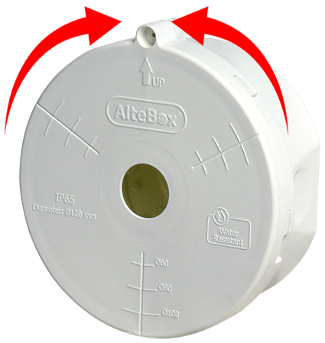


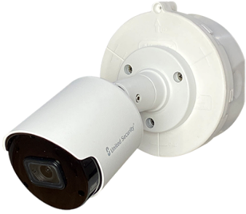

• Easy-to-open lid with twist mechanism
• Easy access to cables
• Weatherproof with gasket
• Spacious interior fits adapters
• Single-screw locking mechanism
• Highly durable material
• UV protection
• IP65 standard with “optional” AB-7006C
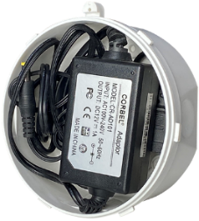

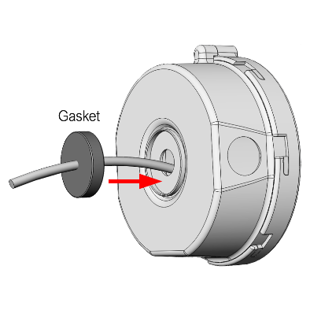
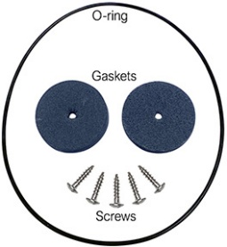

Gasket included AB-7006-C (Optional)

Model | AB-7006 (Click)
Material | PP-GF plastic
UV Protection | UV protected
Max Capacity | Max 3 kg camera
Color Option | White, Black, Grey
Package Content | Junction box + 1 pcs gasket
Pcs in 1 Box | 72 pcs in one box
Net Weight | 120 gr
Dimention | Diameter 120 mm, Height 52 mm
Product Variations
AB-7006B | White, trunking cable enterance
AB-7006S | Black, trunking cable enterance
AB-7006G | Grey, trunking cable enterance
AB-7006BR | White, glands cable entrance
AB-7006SR | Black, glands cable entrance
AB-7006GR | Grey, glands cable entrance
AB-7006C | Optional Oring+gasket+screws
Box Details | 72 pcs (37x37x43 cm 19.6 desi)

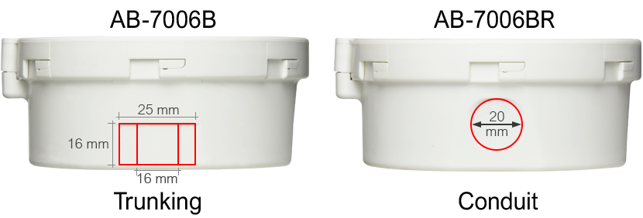
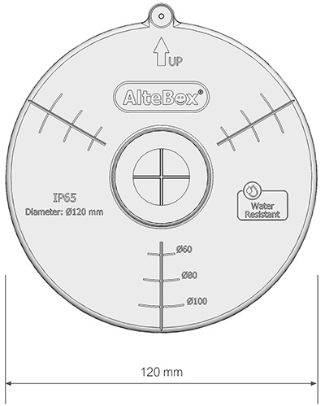
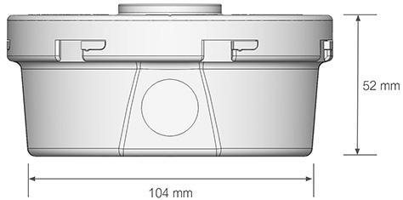
Dimention:
Note: The information in this datasheet may differ from the original.

